**Assignment-A**

**ANDROID/ IOS:**

Create an app with 3 screens

1. First screen will contain a button to view products, Clicking on the button will take user to 2nd screen.
2. Second screen will contain a list of products which will be fetched from API   
   This recyclerview/ tableview will contains two types of items 1st will be a textview with title - “Products List”,  
   Further items will be product list itself.
3. Third screen will contain the detail description of the product. User should navigate to this screen by clicking on any item in the second screen.

**Make sure there is only 1 recyclerview/ tableview with two types of items in the adapter/cell one for title Text and others for products list.**

Refer Wireframe:   
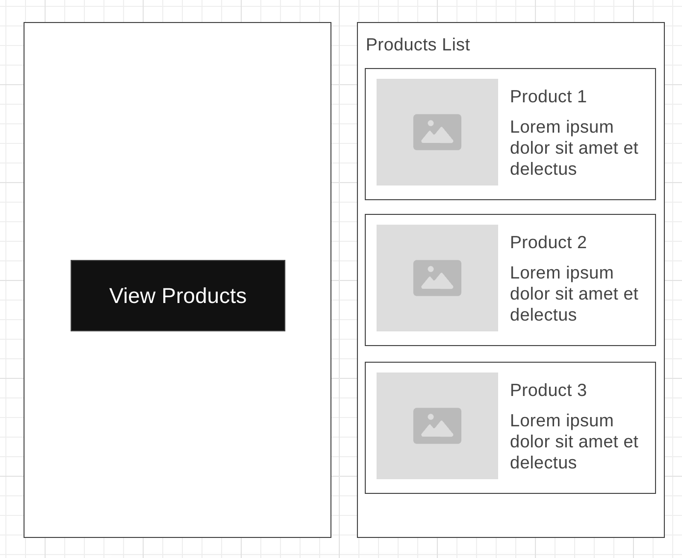

API to use : <https://dummyjson.com/products>   
API type: GET

Notes(Android): Use Retrofit for calling API, Use RecyclerView to display data - Don’t use Jetpack Compose for this Demo. Also, Proper Code quality and Architecture will be a plus.

OR

Notes(IOS): Use Alamofire/URLSessions for calling API, Use tableview to display data. Also, Proper Code quality and Architecture will be a plus. Do not user SwiftUI for this Demo.

**ASSIGNMENT-B**

**BACKEND:**

**MongoDB**

Can you propose a NoSQL or MongoDB schema that a social media platform may use to perform these functions:

a) Register user details

b) Send/Receive and Accept/Reject friend request from users

c) Create text-only posts and comments on their friend's posts.

**Javascript**

If you have to create an Insta or FB like content feed for users, then what sort of operations (or APIs) will be needed?

The Insta/FB feed must fulfil below requirements:

a) A user can see only those posts which were created by their friends

b) A user can see posts of people who are not their friends, only if a friend has posted a comment on it